**Google Summer of Code 2025 Proposal**

Enhancing BEAD for New Physics Detection at LHC Using Multi-source Data Analysis

# Personal Information

Name: Akashdip Mahapatra

Email: akashdipmahapatra2003@gmail.com

GitHub: <https://github.com/akashdip2001>

LinkedIn: <https://www.linkedin.com/in/akashdip2001/>

University: ACADEMY OF TECHNOLOGY

Degree Program: B.Tech, Mechanical Engineering (Final Year)

# Abstract

The Background Enrichment augmented Anomaly Detection (BEAD) project at CERN-HSF targets the detection of rare and unexpected events in LHC data, potentially unveiling new physics beyond the Standard Model. This proposal outlines my plan to contribute to BEAD by leveraging my multidisciplinary background in mechanical engineering, experimental design, embedded systems, and statistics. I aim to support enhancements to the data processing pipeline, background modelling, and latent space diagnostics, incorporating learnings from quality engineering and robust design to optimize performance and noise reduction.

# Benefits to the Community

The development of smarter anomaly detection tools enhances our ability to uncover rare signals in particle physics. By contributing to BEAD, this project will strengthen background enrichment capabilities, ensure better diagnostic tools, and help physicists more confidently isolate meaningful anomalies. My proposed work will also support maintainability and extensibility of the framework, helping future contributors.

# Deliverables

* Enhanced pipeline for background modelling based on data-driven approaches
* Latent space diagnostic tool for visualizing anomalies
* Improved integration and documentation of multi-background learning modules
* Performance evaluation metrics and visualization for comparing background learning methods
* Optional prototype integration of physical sensor anomaly input (IoT-based perspective)

# Timeline

Community Bonding (May 20 - June 17)

* Engage with mentors and study current BEAD architecture
* Explore real LHC datasets, understand anomalies, and study existing ML models
* Review key papers on background modelling in physics

Phase 1 (June 17 - July 15)

* Implement latent space diagnostics for BEAD
* Begin optimizing current background enrichment code
* Conduct tests using synthetic datasets

Phase 2 (July 15 - August 12)

* Integrate visual analytics and evaluation metrics
* Benchmark performance of different background representations
* Document findings for physics and ML audiences

Final Phase (August 12 - September 9)

* Polish code, write developer-friendly documentation
* Prepare detailed performance report and usage examples
* Submit final contributions and GSoC report

# About Me

I am a final-year Mechanical Engineering student who deeply loves physics & statistical methods. My passion for the Large Hadron Collider (LHC) began years ago and **working with CERN as a Physics Lover is a dream come true.** I have:

* Designed a custom voltage and amp controller for electroplating experiments, using the **Taguchi3x3** method for **current density optimization and analysed using Minitab**.

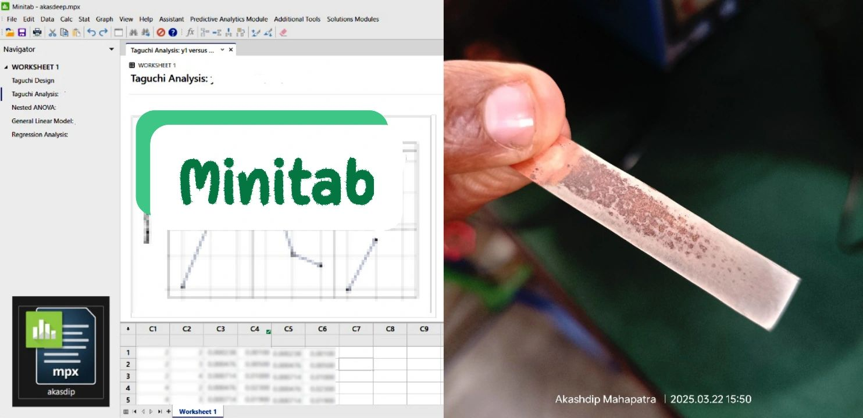

* Developed a **High-end Autonomous Anomaly Detection Robot** using ESP32, ESP8266 &

**Raspberry Pi**, coded in C++ & MicroPython.

* Working knowledge of cloud computing and security, including Google Cloud & AWS.

Reading the book **'Quality Engineering Using Robust Design'** has greatly inspired me. It not only helped me understand signal-to-noise optimization in experimental designs but also resonated with BEAD's approach of enriching background signals to detect rare anomalies. This connection motivated me to apply and contribute to this amazing project.

# Why Me

* Strong foundation in statistics and experimental optimization.
* Experience with embedded systems, data collection and automation.
* Knowledge of cloud platforms, ML libraries, and coding in Python, C++, MicroPython.
* Passion for physics and scientific exploration.

# Technologies & Topics

Python, PyTorch, NumPy, scikit-learn, Matplotlib, MicroPython, C++ (ESP32, Raspberry Pi), Machine Learning, Anomaly Detection, High-Energy Physics, Embedded Systems, Cloud

Computing.

# Experience with Open Source

* Participated in Hacktoberfest, contributed to Python and IoT-based open source projects.
* **GitHub Projects**:

1. Power Supply Control – [GitHub Link](https://github.com/akashdip2001/college-final-year-project) with Transformer, rectifier, DC to DC buck converter, and also create a Alternate Circuit from scratch.
2. Electrical Discharge Machining (EDM) – [GitHub link](https://github.com/akashdip2001/EDM) (also through Network control using Local Area Network LAN).
3. DIY **NAS-with-ESP32** (Network Attached Storage) – [GitHub link](https://github.com/akashdip2001/NAS-with-ESP32)
4. Create my own Local Server – [GitHub link](https://github.com/akashdip2001/ESP32-host-HTML-website) and [YouTube video](https://youtu.be/ySJt3QGyr9w?si=KmLacZyFqzgehyiD).
5. High-end autonomous anomaly detection robot (under development) – [GitHub repo](https://github.com/akashdip2001/High-end-autonomous-anomaly-detection-robot)

* Also Developed many Computer science projects –

My own Login System with PHP & SQL – [video explanation](https://youtu.be/ttJNFAb-qiM) & create an Android app [video explanation](https://youtu.be/9fNjJN3dzpg) which available in [Google Play store](https://play.google.com/store/apps/details?id=com.akashdipmahapatra.freecad&hl=en_IN).

# Future Plans

Post-GSoC, I plan to continue contributing to CERN-HSF and apply the knowledge to pursue research or higher education in physics-focused machine learning, combining mechanical, electronic, and data science disciplines.

# Acknowledgement

Thanks to the mentors and the CERN-HSF community for creating this opportunity and sharing such meaningful projects. I look forward to learning, contributing, and growing together through this collaboration.

